**JavaScript Assignment:**

Q1. To draw patterns using for loop

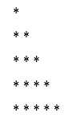 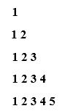

Q2. Print Even and odd number using for loop

Q3. Practice loops and array (book Page No: 385)

Q4. Practice Function and Array (book Page No: 404)

Q5. Practice Function Passing by Reference Example (book Page No: 404)

.